PRACTICAL DBMS
NAME: SIDDHI SRIVASTAVA. P
REG.NO:192521454
COURSE CODE: CSA0503
COURSE NAME: DATABASE MANAGEMENT SYSTEMS

EXPERIMENT NO: 4 DML Commands with Constraints –UPDATE, DELETE
AIM:
To perform Data Manipulation Language (DML) Commands such as UPDATE, DELETE in the table.
Description:
Data Manipulation Language (DML) statements are used for managing data within schema objects. DML
Commands: Update, Delete
➢ UPDATE - updates existing data within a table
➢ DELETE - deletes all records from a table, the space for the records remain
UPDATE:
UPDATE table_name
SET column1=value, column2=value2,...
WHERE some_column=some_value;

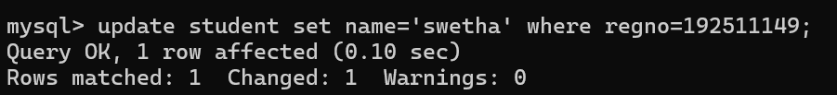
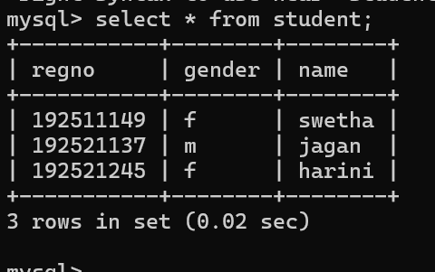

DELETE:
DELETE FROM table_name
WHERE some_column=some_value;
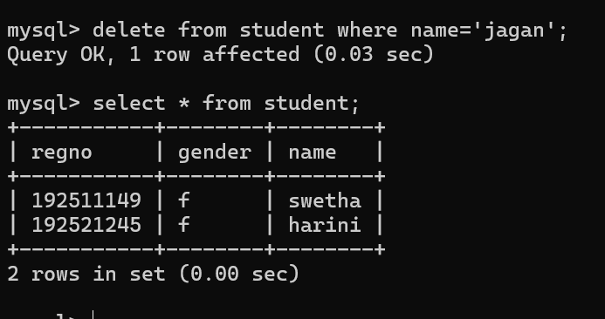

RESULT:
Data Manipulation Language (DML) Commands such as UPDATE, DELETE are performed in the five tables.

